**SMART GARAGE**

**Parikshit sharma**

**Students, B.Tech (IOT)**

Department of CSE,

Chandigarh University,

Chandigarh , India

[19BCS4520@cuchd.in](mailto:19BCS4520@cuchd.in)

**Dr. Monica Luthra**

**Assistant Professor**

Department of CSE,

Chandigarh University,

Chandigarh, India

[monica.e9836@cumail.in](mailto:monica.e9836@cumail.in)

**Er. Gurjot Singh**

**Project Head**

Department of CSE,

Chandigarh University,

Chandigarh , India

[project.ait@cuchd.in](mailto:project.ait@cuchd.in)

**S.V.N.Rahul**

**Students, B.Tech (IOT)**

Department of CSE,

Chandigarh University,

Chandigarh, India

[19BCS4539@cuchd.in](mailto:19BCS4539@cuchd.in)

**Sarabjit Kaur**

**Students, B.Tech (IOT)**

Department of CSE,

Chandigarh University,

Chandigarh, India

[19BCS4536@cuchd.in](mailto:19BCS4536@cuchd.in)

**Ritika**

**Students, B.Tech (IOT)**

Department of CSE,

Chandigarh University,

Chandigarh, India

[19BCS4540@cuchd.in](mailto:19BCS4540@cuchd.in)

*Abstract:* Smart Garage is one such device that will make the life of the user easy. It will also ensure the safety of the garage by sending SMS alerts when it connected to the wifi or cloud. Open and close the garage using Motion or Vehicle detection, detects with and also equipped with a buzzer to ensure that the vehicle is being parked in the garage and the buzzer gives a sound when the garage door is closing. It can be developed in such a way that fully Internet-based in case it is connected with a device like NodeMCU, or ESP32, ESP8266 to get an SMS alert message and a list of the user details like phone number, time, date IP address, location, and device status using Whatsapp chatbox. Due to the current scenario of Covid-19 so as part of our contribution that is preventing the physical touch. This project is being automatic. So as to prevent physical touch we can apply this project into a real-life Application as its low cost, more efficient, easy access at low complexity

***Keywords:*** Arduino+AT328P+MegaWifiR-3,Infra-Red Sensor, DVD writer inside CPU), Jumpers, Buzzer ,LED-Red, Green

Introduction: With the fast-growing world with many inventions and innovations are being made . Making the more complex things into a simpler form by using sensors . With or without our knowledge many things are being automated. As many things are being invented, innovations are being done. As a part of innovation, we are doing this project which is a part of our course i.e IoT. Sensors are one of the important sources which are used for automation. Smart Garage is one such innovation that will make the life of the user easy and secure, automated. It will also ensure the safety of the garage by sending SMS alerts when it connected to the wifi or cloud. Open and close the garage using Motion or Vehicle detection, detects with and also equipped with a buzzer to ensure that the vehicle is being parked in the garage and the buzzer gives a sound when the garage door is closing. It can be developed in such a way that fully Internet-based in case it is connected with a device like NodeMCU, or ESP32, ESP8266 to get an SMS alert message and a list of the user details like phone number, time, date IP address, location, and device status using Whatsapp chatbox. This project helps to reduce the burden of the owner to open the sliding door manually. It will open automatically when you give a motion or when the vehicle is in front of the garage and closes automatically if the car is parked. The main advantage of this innovation is reducing human effort, time, security, automation.

**Main Components Used in the Implementation**:

• Arduino328P+Wifi+Esp8266+ArduinoR-3 *:* It is a custom version of the classic ARDUINO UNO R3 board. Full integration of microcontroller Atmel ATmega328 and IC Wi-Fi ESP8266 with thirty two MB non-volatile storage, and USB-TTL convertor CH340G on one board. All modules will work along or severally.

On the board wherever the switch of a mode of operation with eight position

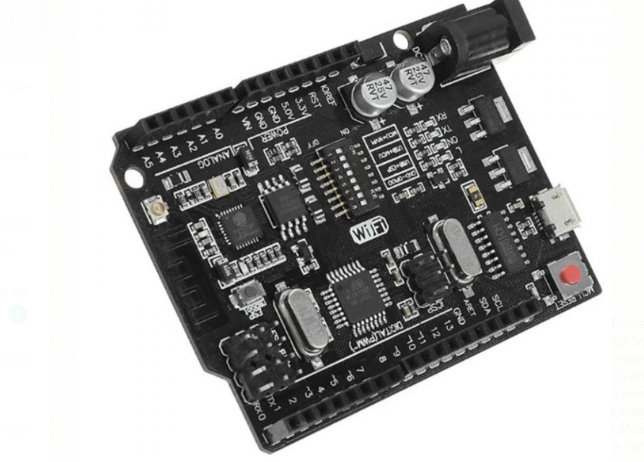

*Fig1:*Arduino328P+Wifi+Esp8266+ArduinoR-3

• DVD Writer(CD-driver present inside the CPU):

DVD Writer uses as a servomotor in our project in this we can connect it with 15volt battery for power and it will act as a shutter of the garage It will open automatically when you give a motion or when the vehicle is in front of the garage and closes automatically if the car is parked. The main advantage of this innovation is reducing human effort, time, security, automation.

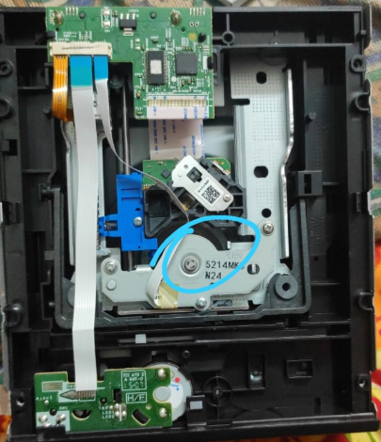

*Fig 2 :* DVD Writer(CD-driver present inside the CPU)

**Infra-red (IR) Obstacle Sensor :**

This IR obstacle avoidance sensor connects to the each slot of the system. IR obstacle avoidance sensor consist transmitter and receiver module. Transmitter sends the pulse and receiver receives the signal. The main workings of sensor are to sense the car and to send the signal to the microcontroller. After that microcontroller take proper action.

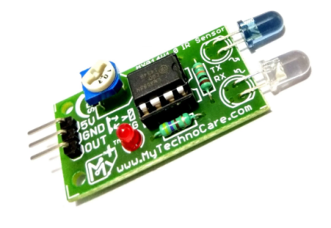

Fig 3: IR Obstacle avoidance sensor

**Implementation:**

When a car or any vehicle Enters or Exits, the IR sensor sends a signal to Arduino and Arduino triggers the particular servo motor and this is how the car Enters, and when anyone parks the car the IR sensor in the Parking slot sends a signal to Arduino and Arduino sends low or 0 signal the particular LED and the LED goes off. This prototype is good for project work only not for implementing on a bigger scale. By this, we came to know that the specific slot is already occupied and the garage is full then it will blink the red light.

**LDR-239-Motor driver**

The L293D motor driver IC actually has two power input pins viz. ‘Vcc1’ and ‘Vcc2’.

Vcc1 is used for driving the internal logic circuitry which should be 5V.

From the Vcc2 pin, the H-Bridge gets its power for driving the motors which can be 4.5V to 36V. And they both sink to a common ground named GND

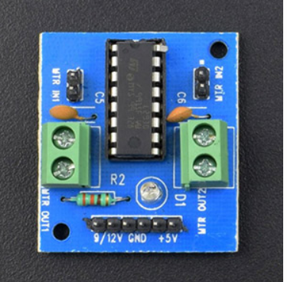

*Fig 4:* LDR-239-Motor driver

**Implementation:** LDR 293 driver is basically used to control the direction that is forward and backward for the things in which for opening it's positive and for the closing reverse of opening that is negative positive so in that case, this is used to control the direction as per our application and gives the output efficiently. It is also used for speed controlling as well.

**Jumpers wires**

A jump wire (also known as jumper, jumper wire, jumper cable, DuPont wire, or cable) is an electrical wire, or group of them in a cable, with a connector or pin at each end (or sometimes without them – simply "tinned"), which is normally used to interconnect the components of a breadboard or other prototype or test.

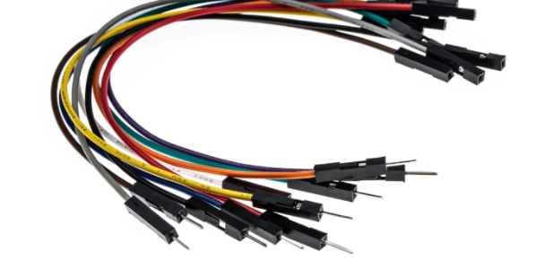

*Fig 5:* Jumpers wires (M to F,F to F)

**Implementation:**

Jumper wire which is normally used to interconnect the components of our project.

**LED- Red ,Green.**

The LED shines one color, either red or green. When the button is closed the other color will light up. So if the LED was green when the button was open, it will change to red when the button is closed.

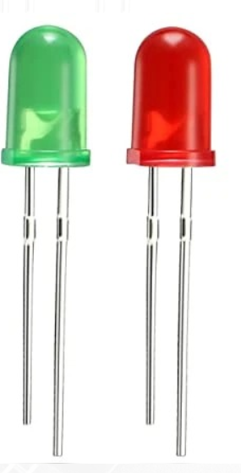

*Fig 6 :* LED

**Implementation:**

Green LED blinks when the garage is empty and when it is full then it will show red light.

**Buzzer**

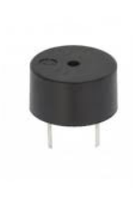

*Fig 7 :* Buzzer

A buzzer or beeper is an audio signaling device, which may be mechanical, electromechanical, or piezoelectric (piezo for short). Typical uses of buzzers and beepers include alarm devices, timers, and confirmation of user input such as a mouse click or keystroke.

**Resistors 10ohm**

A resistor is a passive two-terminal electrical component that implements electrical resistance as a circuit element. In electronic circuits, resistors are used to reduce current flow, adjust signal levels, divide voltages, bias active elements, and terminate transmission lines, among other uses.

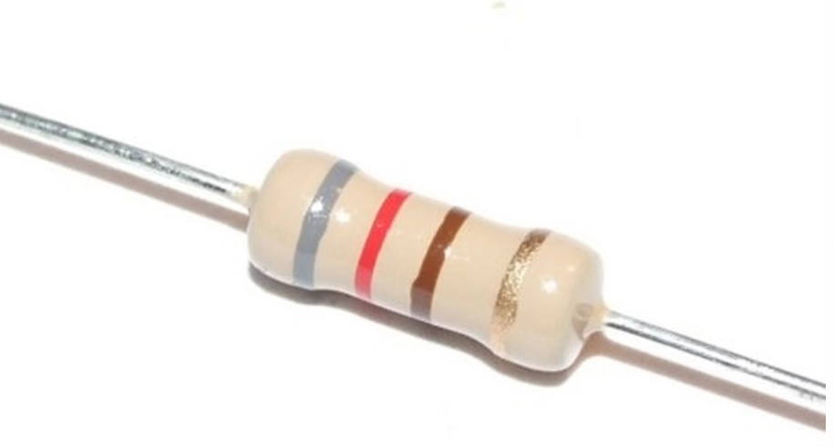

*Fig 7:* Resistor

**Twilio SMS Messaging API**

Twilio’s Programmable SMS API helps you add robust messaging capabilities to your applications.

 Fig 8:(Python code for SMS)



Fig 9:(Twilio sandbox for WhatsAap)

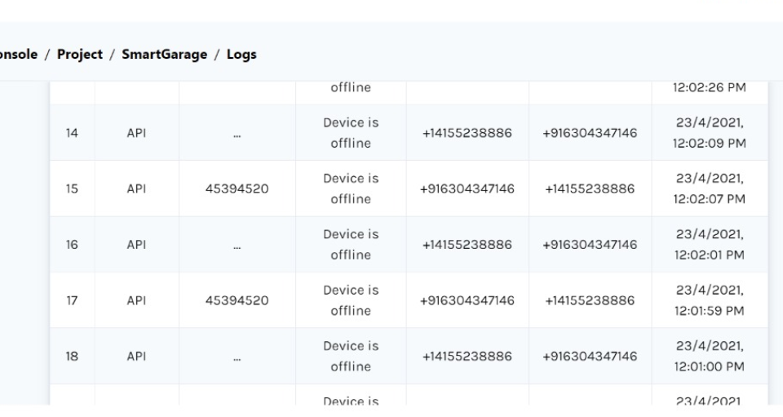

Fig 10(Details about the garage user)

**Implementation:**

In our project it is use to store the details about the garage like user phone number, time, date IP address, location, and device status using Whatsapp chatbox.

‘

**1.2 How to make an Switching Sliding Door**

CASE-1:When switch is OFF

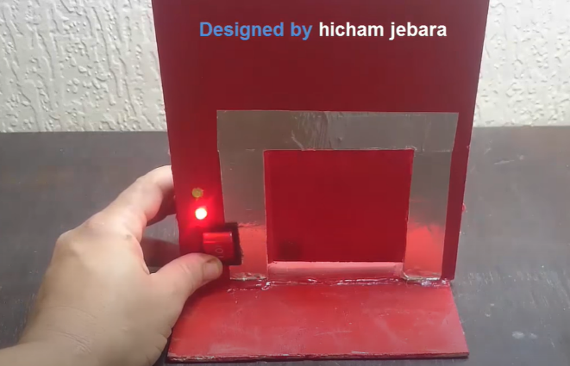

Fig 11: (switch off)

CASE-2: WHEN SWITCH IS ON

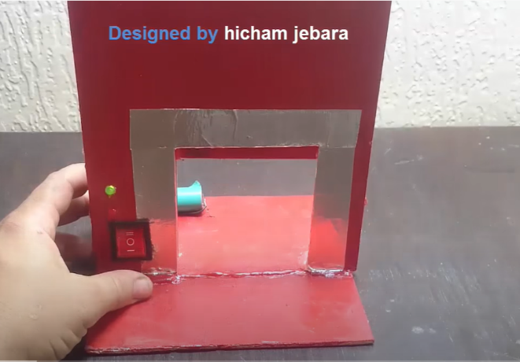

Fig12: (Switch ON)

CASE-3:Sliding shutter

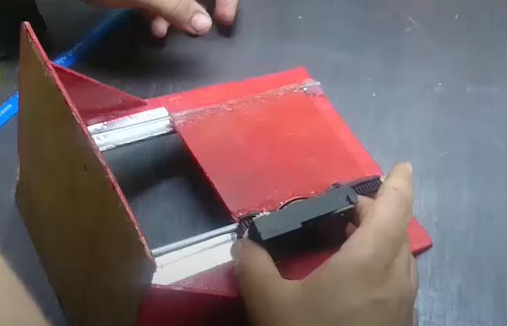

Fig13: (Sliding shutter)

**Implementation:**

This is a reference which we have taken for implementing our project. This actually deals with the switching mechanism. Components used in this reference project are a relay, DVD-writer, etc. In this, the sliding mechanism is performed with the help of the sliders which are present inside the DVD writer. The main objective is if we on the switch this door opens and if the switch is pressed again it switches off so that the door closes . We have taken the usage of CD-drive for the opening of the garage without any human intervention or effort even the switching etc, everything is automated, The door opens when the vehicle1 is in front of the garage, the door opens and vehicle1 goes in and it also gives a buzzer and red light outside as a signal to wait, as the vehicle1 is being parked in the garage and the other vehicle2 realize the signal and wait till the vehicle1 is parked in and later this also get parked in the garage. This system is in order to follow a systematic behavior, and prevents accidents, ensures security, reduces human effort, time etc.

**Some Issues arise with this approach :**

1. Actually, the board used in this project is a Hybrid board which is a combination of General Arduino Uno and Wifi module i.e ESP-8266, but due to some board default this is not being operated with Wifi applications like Twilio, IFTTT are mentioned clearly how to configure and develop these applications and advantages and benefits of being online.

2. Another issue is Google assistant can be developed only when there is one and only one output in this project we are using two things for opening or closing in that case one should be High and another should below at the same time so google assistant cannot be generating two things at a time so this is one of the issues which has raised while developing the project.

### 2. Innovation in modelling :

### This project is one of the innovative aspect, One of the major innovations of this project is Arduino board i.e Arduino+AT328P+Wifi+UnoR-3, it is basically a hybrid board which can be used as Genera Arduino, WifiArduino, ESp8266 applications, WIfi+Arduino applications, Node MCU applications. But we have used the general Arduino for this project purpose. This project made us learn many things about Wifi connections, IFTTT, Twillio, Google assistant, Arduino.

### This project has come up with an innovation i.e Smart Systematic Lighting .

**Link for Twilio video stimulation:**

<https://drive.google.com/drive/folders/1R6--HmghKBWTM-taybng4zJeUo63Bprp?usp=sharing>

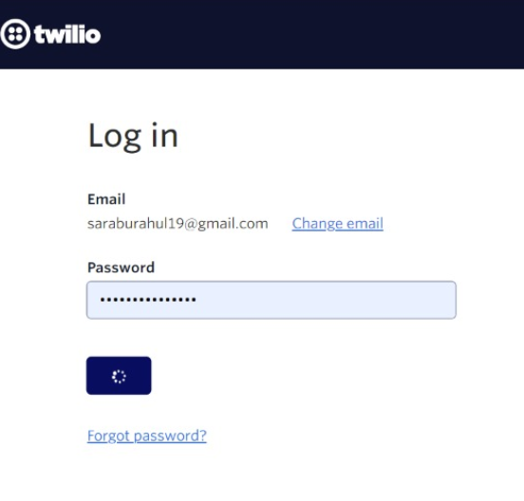

Fig14 (Login to Twilio account)

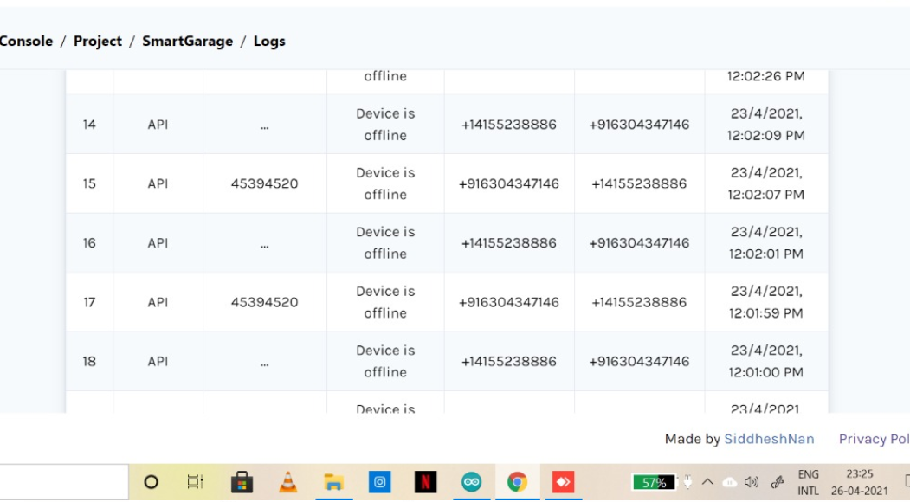

Fig 15 (Status of user of garage)

**Link for Google assistant connected by IFTTT(Stimulation)**

<https://drive.google.com/drive/folders/1kzgAZtn7fahrOeusAW5ZwpBbZm4e2b6p?usp=sharing>

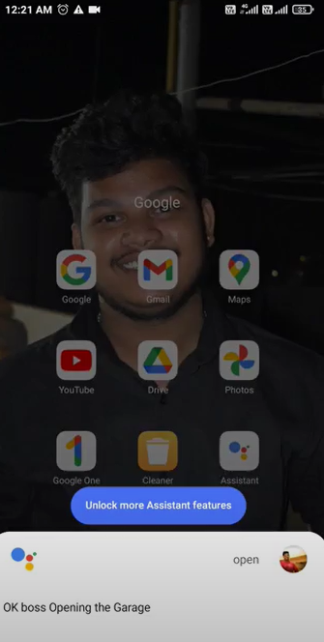

Fig 16: (Google assistant connected by IFTTT)

### Case-1: On Vehicle comes and gets it parked without any hassle.

### The smart systematic lighting concept is one of the unique features of our project that helps garage safety, vehicle safety. This actually works with Two lights one is red and another one is green, As we all know that green is used for going and red is used for stopping as a part of traffic lights. So the same is concept is being applied here that is Consider if there are two vehicles vehicle1,vehicle2.

### Vehicle 1 has come to the garage and it's being parked and garage recognizes the vehicle and gives a signal to Arduino so that it activates the red light, the green light,door gets opened, buzzer also gives a sound.

### Case -2: Two Vehicles come simultaneously one is in the garage and the other should be outside. the same time vehicle 2 has arrived at the garage vehicle 1 is being parked so if two cars at the same time go in there may be an accident for the vehicles this may lead to some damage so in order to prevent that situation that the concept of Smart systematic lighting is being used Vehicle 2 recognize the red light and buzzer sound, wait until the Vehicle1 is being parked and then park the vehicle 2 accordingly.

3. Due to the current scenario of Covid-19 so as part of our contribution that is preventing the physical touch.This project is being automatic. So as to prevent physical touch we can apply this project into a real-life Application as its low cost, more efficient, easy access at low complexity

**2.1 Components :**

1. Arduino328P+Wifi+Esp8266+ArduinoR-3

2. Infra-Red Sensor

3. DVD Writer(CD-driver present inside the CPU)

4. LDR-239-Motor driver

Jumpers wires

5.LED- Red ,Green.

6. Buzzer

7. Resistors 10ohm

8.Relay

**2.2 Need of terminology:**

1. As the number of vehicles is increasing, the problems faced by the manual parking management system and safety of the car are also increasing. Such problems can be eliminated to some extent by implementing an intelligent smart garage System.

2.This system can help in reducing cost, increase productivity, and saves time.

3. Accurate timing details about the user can be measured with the help of Twilio API. Therefore, the Complexity of the model is also less.

4. Due to the current scenario of Covid-19 so as part of our contribution that is preventing the physical touch. This project is being automatic. So as to prevent physical touch we can apply this project into a real-life Application as its low cost, more efficient, easy access at low complexity

**3. Model Representation:**

Link for project details:

<https://saraburahul19.wixsite.com/my-site-1> 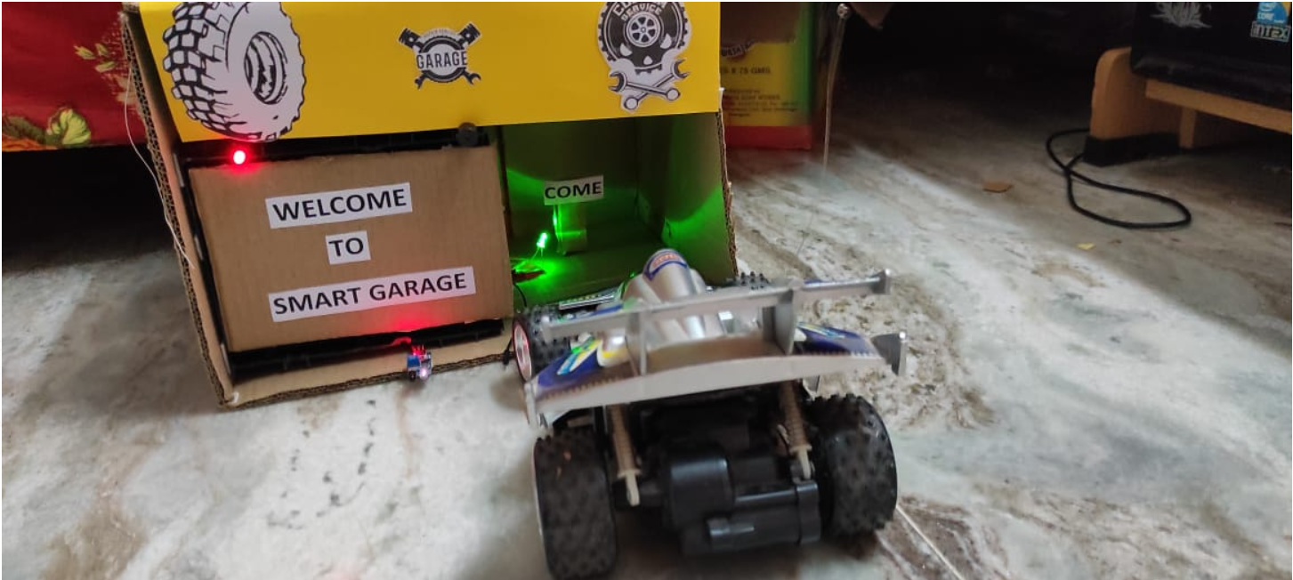

Fig 17:( When the garage is open)

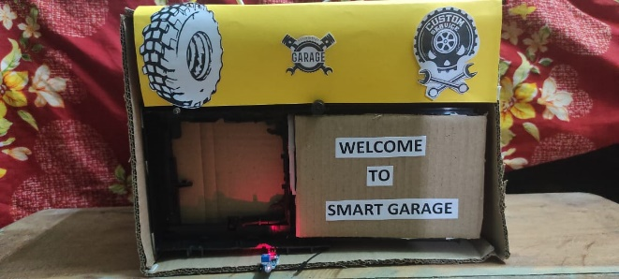

Fig 18:(When garage is close)

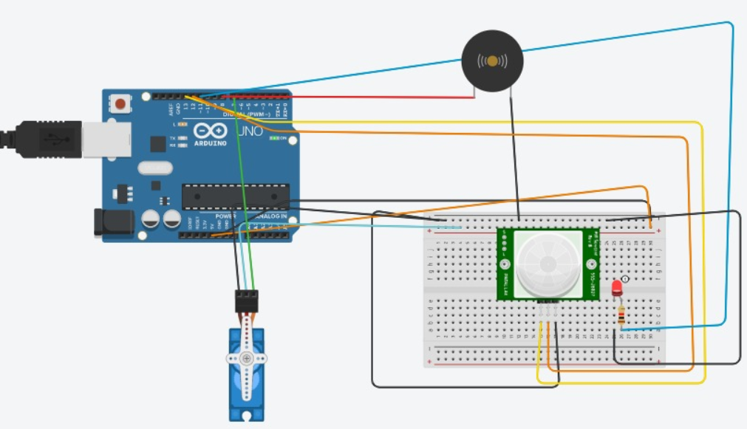

Fig 19: (Model Representation in TinkerCad)

**3.1 Flowchart:**

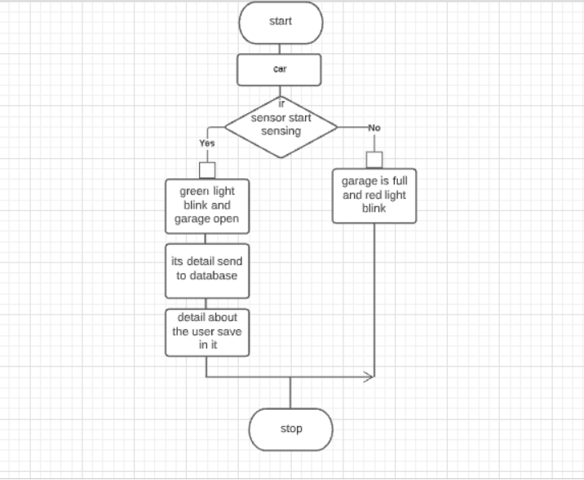

*Fig 20 :* Flowchart

**3.2 Detailed Explanation of Components:**

Arduino(CC)

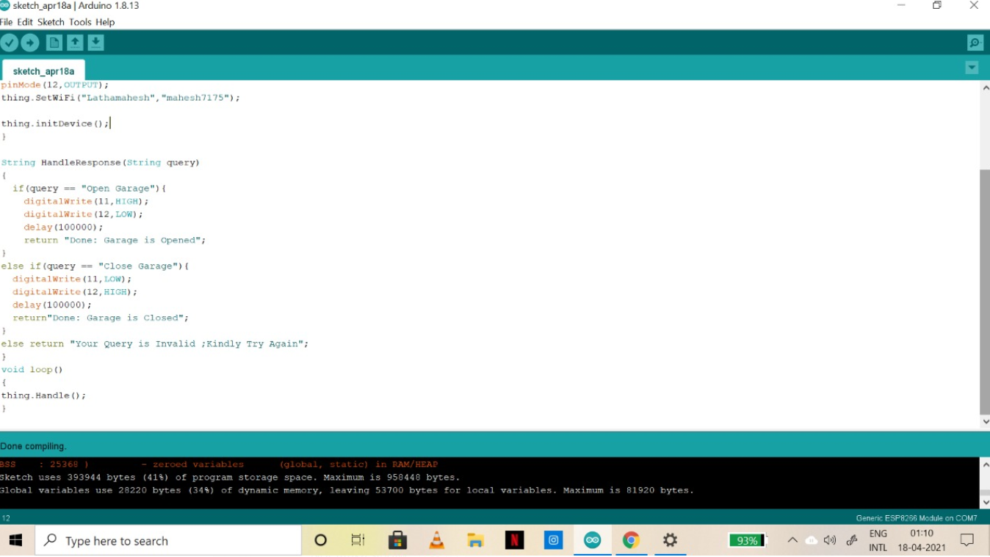

Fig 21: (Code in Arduino CC)

**Code:**

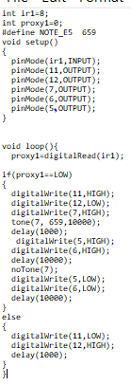

Fig 22: (Code )



Fig 23:( TinkerCad)

**3.3 Simulation :**

Hardware stimulation:

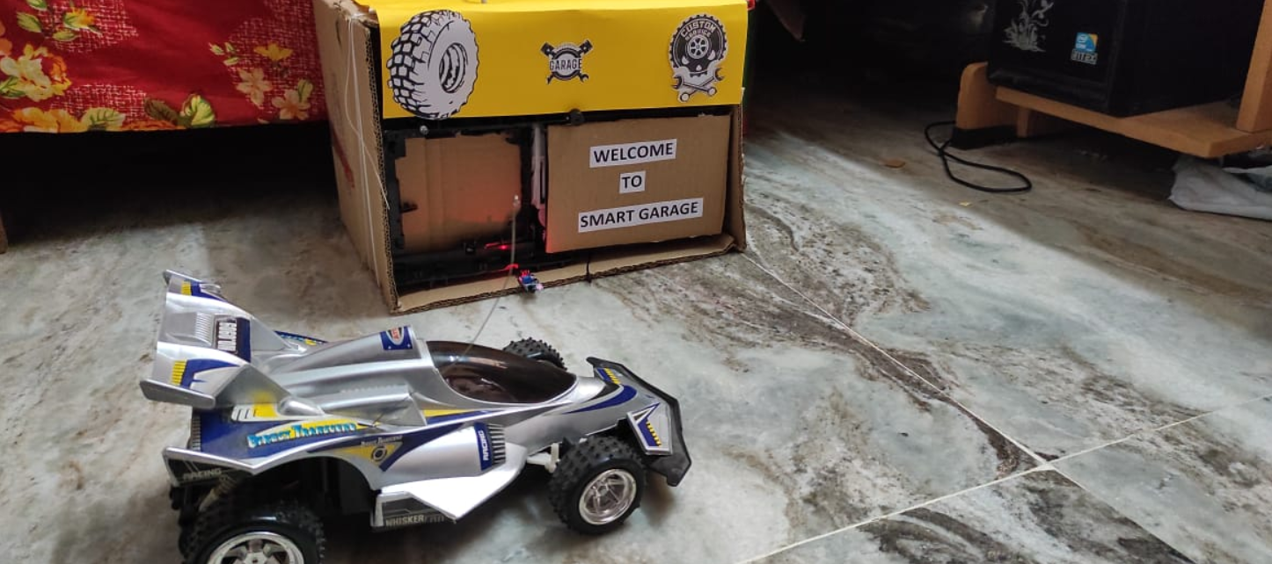

Fig 24: (Smart Garage Hardware pic)

Link video Stimulation:

<https://drive.google.com/drive/folders/19RpQTaqnTLzCoxQynsF8NnvPK4XjMKaV?usp=sharing>

TinkerCad Stimulation



Fig 25:(TinkerCad model )

Link TinkerCad Stimulation:

https://drive.google.com/drive/folders/1Co3mKJwZI3SvVHLU_---sYZzGRVKua3Y?usp=sharing

**3.4 Application Area:**

1. Due to the current scenario of Covid-19 so as part of our contribution that is preventing the physical touch. This project is being automatic. So as to prevent physical touch we can apply this project into a real-life Application as its low cost, more efficient, easy access at low complexity

2. It can be used in Market places, homes, cinemas, hotels, hospitals, etc.

3. This actually works with Two lights one is red and another one is green, As we all know that green is used for going and red is used for stopping as a part of traffic lights.

4. One of the major applications of this project is the Arduino board i.e Arduino+AT328P+Wifi+UnoR-3, it is basically a hybrid board that can be used as Genera Arduino, WifiArduino, ESp8266 applications, WIfi+Arduino applications, Node MCU applications. But we have used the general Arduino for this project purpose. This project made us learn many things about Wifi connections, IFTTT, Twillio, Google assistant, Arduino.

**4. Progress Report**

**4.1 Project Completion :**

The project stimulation is successfully done on Tinkercad software and coding is done in Arduino CC software. The desired output is achieved. All the parameters/Targets as proposed are accomplished.

This project is done by the Arduino and all the connections like DVD-Writer to Arduino, LDR-293 to Arduino, CD-drive, LED, BUZZER, connections from IR to Arduino are done successfully. The Arduino code for this project is compiled successfully without any hassle. And the code does not contain any errors. And all the delays are given as per our requirement and application and as per expected output the project is finalized and got the desired output.

**4.2 Target Accomplishment :**

1 Firstly as per the project motive the door should open /close without any human intervention.

2 The IR sensor should detect the vehicle and open the garage automatically without any physical effort and close after the vehicle is parked.

3.The other important feature is Smart Systematic Lighting The smart systematic lighting concept is one of the unique features of our project that helps garage safety, vehicle safety. This actually works with Two lights one is red and another one is green, As we all know that green is used for going and red is used for stopping as a part of traffic lights. So the same is concept is being applied here. This feature is also done successfully.

4. The innovative part is one of the best features due to the current scenario of covid -19 that this project helps to prevent physical touch and prevent from being attacked from that virus.

All of the proposed targets are successfully accomplised.

**4.3 Solution Validation :**

Basically, this project is done to prevent physical touch due to the current scenario of the COVID-19.

As physical touch major cause of spreading this virus to prevent people from this problem, we have come with the solution of the smart garage door.

**Test cases for this Project.**

1: Vehicle 1 has come to the garage and it's being parked and garage recognizes the vehicle and gives a signal to Arduino so that it activates the red light, the green light, door gets opened, buzzer also gives a sound

2: Two Vehicles come simultaneously one is in the garage and the other should be outside. At the same time vehicle 2 has arrived at the garage vehicle 1 is being parked so if two cars at the same time go in there may be an accident for the vehicles this may lead to some damage so in order to prevent that situation that the concept of Smart systematic lighting is being used Vehicle 2 recognize the red light and buzzer sound, wait until the Vehicle1 is being parked and then park the vehicle 2 accordingly

So, All the Test Cases are executed successfully and the result of the testing parameters are within the expected scale.

**4.4 RESULT:**

Video Link: [Hardware stimulation: - Google Drive](https://drive.google.com/drive/u/1/folders/19RpQTaqnTLzCoxQynsF8NnvPK4XjMKaV)

<https://drive.google.com/drive/folders/19RpQTaqnTLzCoxQynsF8NnvPK4XjMKaV?usp=sharing>

CASE 1: Vehicle 1 has come to the garage and it's being parked and garage recognizes the vehicle and gives a signal to Arduino so that it activates the red light, the green light, door gets opened, buzzer also gives a sound.

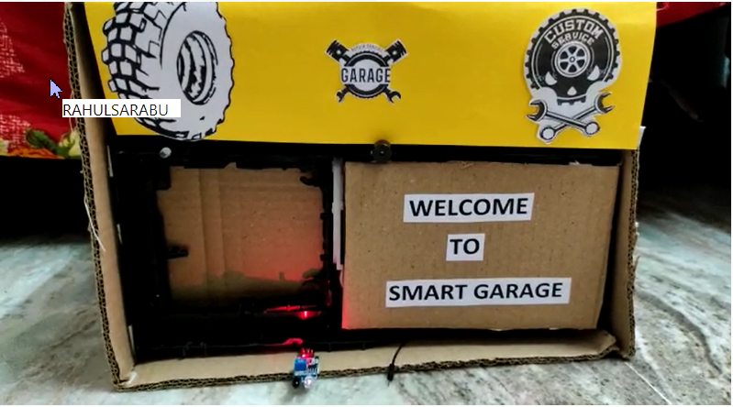

Fig 26:( garage is close)

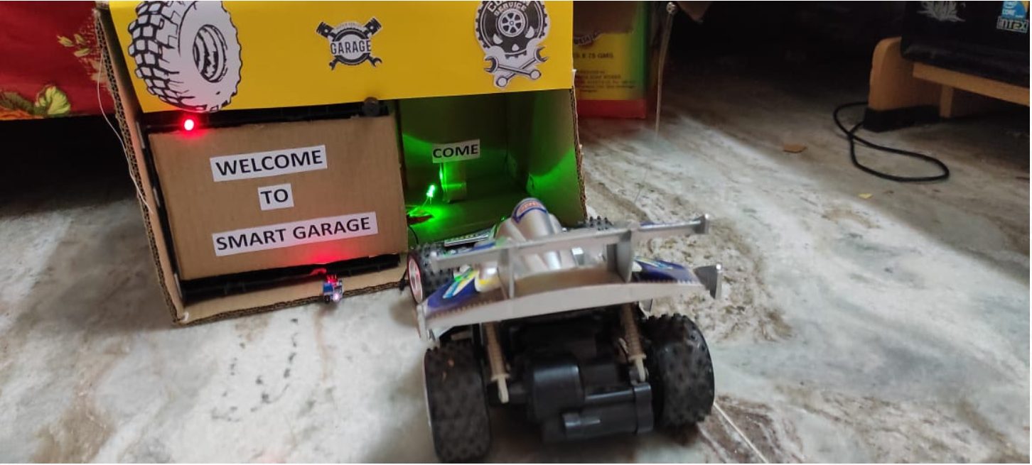

Fig 27:(Vehicle is entering into garage)



Fig 28:(Vehicle is parked inside)

CASE 2:Two Vehicles come simultaneously one is in the garage and the other should be outside. At the same time vehicle 2 has arrived at the garage vehicle 1 is being parked so if two cars at the same time go in there may be an accident for the vehicles this may lead to some damage so in order to prevent that situation that the concept of Smart systematic lighting is being used Vehicle 2 recognize the red light and buzzer sound, wait until the Vehicle1 is being parked and then park the vehicle 2 accordingly

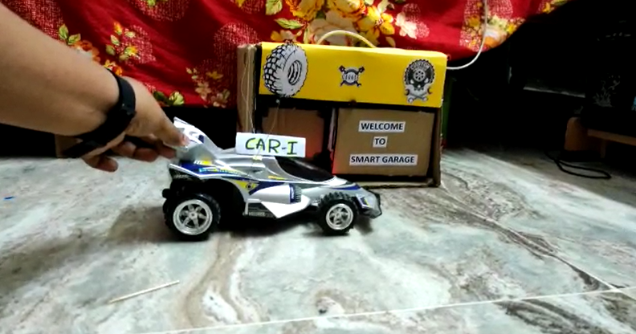

Fig: 29:(Car 1 come)



Fig 30:(Car 1 is parked inside)

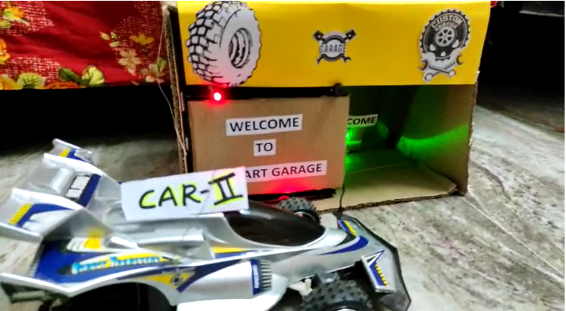

Fig 31:( Car 2 is Waiting for its turn, because Car 1 is being parked inside and red light buzzer indicates to wait)

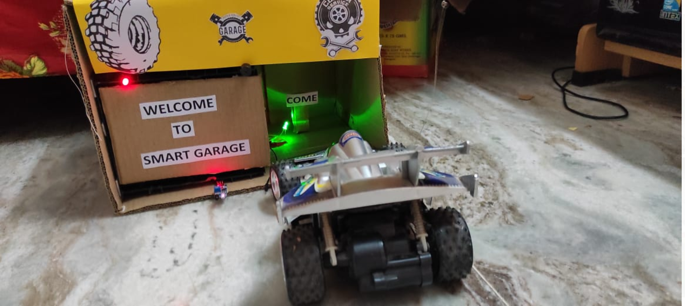

Fig 32(Both the car parked successfully)

**4.5 Discussion and Comparison:**

This is a reference which we have taken for implementing our project. This actually deals with the switching mechanism. Components used in this reference project are a relay, DVD-writer, etc. In this, the sliding mechanism is performed with the help of the sliders which are present inside the DVD writer. The main objective is if we on the switch this door opens and if the switch is pressed again it switches off so that the door closes . We have taken the usage of CD-drive for the opening of the garage without any human intervention or effort even the switching etc, everything is automated, The door opens when the vehicle1 is in front of the garage, the door opens and vehicle1 goes in and

it also gives a buzzer and red light outside as a signal to wait, as the vehicle1 is being parked in the garage and the other vehicle2 realize the signal and wait till the vehicle1 is parked in and later this also get parked in the garage. This system is in order to follow a systematic behavior, and prevents accidents, ensures security, reduces human effort, time etc

**Conclusion:**

In conclusion, this project can be used at all places starting from domestic to industrial sectors. The simplicity in the usage of this circuit helps it to be used by a large number of people as people with less knowledge of hardware can also use it without facing any problem. The automatic smart garage will save us some time and increase the security of the vehicle.

**Acknowledgment:**

Firstly, we are thankful to Dr. Monica Luthra, Assistant Professor of the CSE department, Chandigarh university. He guided us on the right path and polish our skills. Today, with the help of mam, we are very close to completing our project. Special thanks to our university who provided us an opportunity to do something out of the box.

**References:**

1. [สอนใช้งาน Arduino UNO+WiFi R3 ATmega328P+ESP8266 Web Server Wifi - YouTube](https://www.youtube.com/watch?v=TCpA1nhfG6A)

2. [Send WhatsApp Messages to ESP32, ESP8266 & NodeMCU using Twilio API and ThingESP - YouTube](https://www.youtube.com/watch?v=in3W1d_BpXw)

3. [How to make Automatic Sliding Door/ Easy Tutorial - YouTube](https://www.youtube.com/watch?v=3hEipRDH3_o)

4.https://thingesp.siddhesh.me/#/console/home

5. <https://www.twilio.com/>

6. https://ifttt.com/home